BEEE LAB EVALUATION

NAME: PRATEEK KUMAR VERMA

UID: 19BCS4658

CLASS: IOT (2)

**QUESTION**

26. Design a system for LPG gas burners such that, whenever it is turned on, a green LED starts blinking and if it stays on for more than 2000ms , instead of the green LED, a Red LED starts blinking.

**APPARATUS:**

1. BREADBOARD
2. ARDUINO
3. CONNECTING WIRES
4. GREEN LED
5. RED LED
6. TWO RESISTORS
7. TEMPERATURE SENSOR

**Circuit diagram**

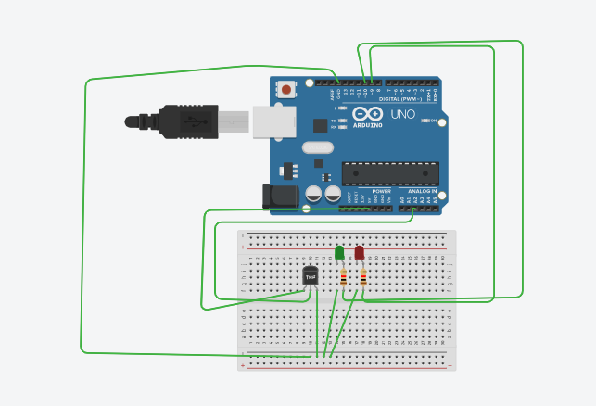

**SOURCE CODE:**

const int hot = 87;

const int cold = 75;

int i=0;

void setup()

{

pinMode(A2, INPUT);

pinMode(10, OUTPUT);

pinMode(9, OUTPUT);

Serial.begin(9600);

}

void loop()

{

int sensor = analogRead(A2);

float voltage = (sensor / 1024.0) * 5.0;

float tempC = (voltage - .5) * 100;

float tempF = (tempC * 1.8) + 32;

Serial.print("temp: ");

Serial.print(tempF);

if(tempF >=hot){

for(i=1;i<=5;i++){

digitalWrite(10,HIGH);

delay(200);

digitalWrite(10,LOW);

delay(200);

}

digitalWrite(10,LOW);

while(1){

digitalWrite(9,HIGH);

delay(200);

digitalWrite(9,LOW);

delay(200);

}

}

}